Sample of the Abstract for the Annual Symposium of the VSJ

Vacuum Society of Japan R&D Center¹ Organization of Vacuum Science²
ºTaro SINKU¹, Ichiro SUZUKI², Clark KENT²

- 1. Introduction
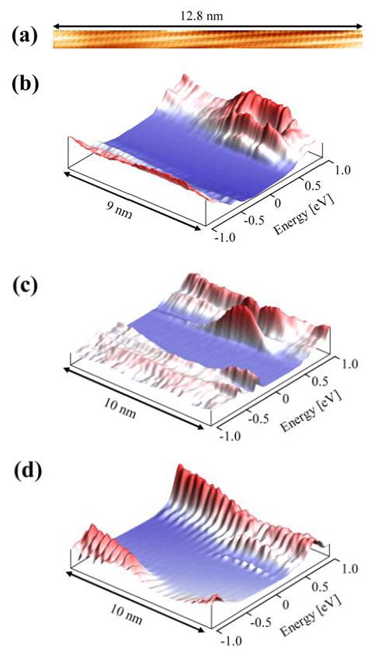
Fig.1. FFFF IIIII GGGGG UUU RRRR EEE Caption comes here......
This file is an English edition of a prototype of MS-Word sample showing a basic guidelines for preparing manuscripts for the proceedings of the Annual Symposium of the Vacuum Society of Japan¹⁾.

- 2. Manuscript preparation

Manuscripts should be written on vertical A4 size paper (210 x 297 mm). The text should be typed in single or double column format with 10 to 11 pt font size. Times or similar fonts are recommended ²⁾.

References
1) K. Tanaka, H. Waki, Y. Ido, S. Akita, Y. Yoshida, T. Yoshida : Rapid Commun. Mass Spectrom., 2 (1988) 151.
2) G. Horikoshi: J.Vac. Sci. Technol. A 5 (1987) 2501.

