Recent Developments in Vacuum Science and Technology*
Kazuo SHINKU*¹, Blaise PASCAL*² and Heng ZHANG*³

*¹Department of Vacuum Engineering, University of Vacuum Science and Technology,
3-5-8 Shiba-koen, Minato-ku, Tokyo 105-0011, Japan
*²Département de physique, Université Blaise Pascal,
34 Av. Carnot, F-63006 Clermont-Ferrand, France
*³Dipartemento di Fisica, Università degli Studi di Padova,
via 8 Febbraio, 2, 35122 Padova, Italy

(Received , Accepted )

*Presented as an invited talk at the 50th annual symposium of the Vacuum Society of Japan, Nov. 5, 2009
Abstract

Original papers and Reviews must have an abstract written on a separate page from the title page and the body. Articles other than Original papers and Reviews may have an abstract if necessary. The abstract should not exceed 150 words and be easy to understand when standing alone. Reference to equations, figures, tables or references is not allowed. Keep it in mind that the abstract should be written in clear English to be offered to J-STAGE, a worldwide web site ( http://www.jstage.jst.go.jp/browse/jvsj2 ).
- Introduction

Carefully read the “Information for the Contributors” and “Instructions for the Preparation of Manuscripts” those are available at http://www.vacuum-jp.org/EDT/TokokiteE.pdf. Authors are expected to follow the conventional writing, notation, and illustration styles. Authors should also study the form and style of the printed material in this journal. Authors are recommended to access the web site of the Vacuum Society of Japan (VSJ) at http://www.vacuum-jp.org.

- Instructions for the preparation of manuscripts

Manuscripts should be prepared using a prescribed template in a MS-Word format available at the web site http://www.vacuum-jp.org/EDT/TemplateE.doc (double-spaced, 64 letters in one line and 32 lines on one page). A title page should precede the abstract and the body of the manuscripts, followed by references, captions for figures and tables, figures, and tables. Avoid using prevailing technical terms that are not recognized by official organizations. See JIS Z8126･1, 2, and 3 (1999) obtainable at the web site (http://www.jisc.go.jp). Please refer to “Information” in Shinku 44, No. 6 (2001) for terms recognized in the field of vacuum science and technology. Abbreviations, such as ECR, TMP, and AES, are not permitted in titles. Estimate the length of the manuscripts, taking the size of figures into consideration.
2.1 Abstract
Original papers and Reviews must have an abstract written on a separate page from the title page and the body. Articles other than Original papers and Reviews may have an abstract if necessary. The abstract should not exceed 150 words and be easy to understand when standing alone. Reference to equations, figures, tables or references is not allowed. Keep it in mind that the abstract should be written in clear English to be offered to J-STAGE, a worldwide web site (http://www.jstage.jst.go.jp/browse/jvsj2).
2.2 Body
Chapters are numbered in the form 1., whereas sections and subsections are numbered in the form 1.1. and 1.1.1., respectively. Use SI units, particularly Pa for pressure. Symbols are written in italics to indicate quantities and in solid style to indicate units and atomic elements. Greek letters should be carefully introduced.
2.3 Mathematical formula
Express mathematical formulae and equations to ensure clear reproduction upon printing. Avoid double upper (lower) case letters and use exp instead of e for exponential functions. In-line formulae and equations should be written in the form a/b, exp (-t/τ). Make two or three lines available for one mathematical formula or equation. Mathematical formulae and equations are usually written in italics.
2.4 Figures and tables
Figures should be drawn clearly. The captions including the titles of the figures (and tables) should be presented on separate pages of the manuscripts. Begin with a capital letter and end with a period. Prepare figures and tables on separate pages. Number figures as Fig. 1, Fig. 2 . . . . , and tables as Table 1, Table 2 . . . . The figure (and table) number, along with the name(s) of the author(s), should be written in a corner on the front of each figure page. The printed size of a figure can be chosen from small (8.5 cm wide, Fig. 1) or large (17.5 cm wide, Fig. 2). The height is limited to 25 cm in either case. Indicate “S” or “L” in a corner of each figure. The best original figures are twice as large as the printed ones. Inappropriately sized lettering on a figure may be reduced to a size less than optimum. The lettering used in a figure should be chosen such that after reduction, the height of numbers and capital letters falls within the range 1.2-2.4 mm. Care should also be taken in choosing the pen width. Lines in figures are frequently too fine compared with the size of the figure, resulting in problems on reduction. Shaded areas should be shown by means of cross-hatching (or a matrix of dots) rather than a continuous grey “wash”. Cross-hatching, after reduction, with a density less than ~25 lines/cm is satisfactory. A request to print figures in color on the basis that they are essential for the presentation may be considered by the editorial board. There will be a fee for printing figures in color.
2.5 Footnotes and list of references
Indicate *, ^{*1}, ^{*2}, . . . as superscripts and prepare corresponding footnotes in the footer. References must be in English, and they should be numbered in the order in which they first occur in the text. Reference numbers should be given in the text as superscripts with a right-handed parenthesis¹⁾.
In the list of references, the initials and names of all authors (comma-terminated) must be given, followed by the colon-separated complete reference¹⁾. The volume number is in bold. The use of, for example, ibid. is not permitted. References to unpublished or not readily available work should be avoided. References should be cited with standard journal title abbreviations. Please refer to the web sites http://authors.aps.org/STYLE/style_jabbr.html, http://www.ieee.org/portal/cms_docs_iportals/iportals/publications/journmag/transactions/tjmnames.pdf, and http://wwwsoc.nii.ac.jp/vsj/EDT/JournalTitleAbbreviation.pdffor the list of journal title abbreviations. The journal titles with an alphabet such as “Phys. Rev. B”, “Nucl. Instrum. Methods Phys. Res. B”, and “J. Vac. Sci. Technol. A” must not include a comma before the alphabet²⁾.
This journal up to Vol. 50 (published in 2007) must be cited as “Shinku”, which is the old series of J. Vac. Soc. Jpn. Please refrain from referring to the modern title of the journal in old references³⁾. All later volumes of this journal (Vol. 51 and later) must be cited as “J. Vac. Soc. Jpn.”⁴⁾.
For a citation from a book, the title of the book is in italics, and the publisher, the place of publication, and the year of publication are enclosed in parentheses^{5,6)}.
For the proceedings of a conference, give the authors (colon-terminated), the title of the proceedings (in italics), the place and year of the conference, the volume (in bold) followed by the publisher, the place of publication, and the year in parentheses in accordance^{7,8)}.
2.6 Use of English
The authors are responsible for the use of English. It is highly recommended to get the manuscripts revised by native English speakers before submission.

3. Submission of the manuscripts

Submit the manuscripts at the web site http://mc.manuscriptcentral.com/jvsj2/. The copyright transfer to VSJ must be agreed on the submission of a paper. Please contact the VSJ office if the complete copyright is not to be transferred.

4. Proofreading of the article

Proofreading of the article should be carried out carefully on the responsibility of authors. Major alterations of the proof should be avoided. The title and the name of authors must be proofread carefully. The present address should be added in the footnote when the affiliation of authors has been changed. Confirm that the following points those are easy to mistake are correctly printed: Upper- and lower-case letters, Greek letters, bold, italics, and characters that may be misinterpreted. Confirm that the characters in the figures and tables, the position of the figures and tables, and captions of the figures and tables are correctly printed. When references are published after sending the final version of the manuscripts, the volume number, published year, and page number must be added. Confirm that the formats of the references are correctly printed in English. Confirm that the name of authors, journal/book title, volume number, published year, and page are correctly printed. Note that references in Japanese or those contain a typographical error will not be linked in the J-STAGE ( http://www.jstage.jst.go.jp/browse/jvsj2 ).
References

1) T. B. Lindemar, R. L. Pearson and K. Inoue: J. Nucl. Mater., 55 (1975) 359.
2) M. Sasaki, Y. Yamada, Y. Ogiwara, S. Yagyu and S. Yamamoto: Phys. Rev. B, 61 (2000) 15653.
3) K. Suzuki: Shinku, 33 (1990) 371.
4) M. Kogoma: J. Vac. Soc. Jpn., 51 (2008) 2
5) O. Kubaschewsky and C. B. Alock: Metallurgical Thermochemistry (Pergamon Press, Oxford, 1979) p. 65.
6) M. Nakamura and Y. Nakagawa: in Handotai (Semiconductor), ed. NameOfEditor (Shokabo, Tokyo, 1985) 2nd ed. Vol. 2, Chap. 2, p. 85 [in Japanese].
7) K. Kajimura: Proc. 3rd. Int. Symp. Reinstoffe in Wissenschaft und Technik, Dresden, 1985 (Akademie-Verlag, Berlin, 1986) p. 166.
8) K. Tasaka: Proc. 7th Int. Conf. on Emerging Nucl. Energy Systems, Chiba, Japan, 1993, 2 (1994) 203.
Figure and table captions

Fig. 1 Example of a small figure (8.5 cm wide). Figures should be drawn clearly.

Fig. 2 Example of a large figure (17.5 cm wide). The captions including the titles of the figures (and tables) should be presented on separate sheets of the manuscripts. Begin with a capital letter and end with a period. The captions must be written in clear English.

Table 1 Example of a table (price list of the reprints). Prepare figures and tables on separate sheets. Number figures as Fig. 1, Fig. 2 . . . . , and tables as Table 1, Table 2 . . . . The figure (and table) number, along with the name(s) of the author(s), should be written in a corner on the front of each page.

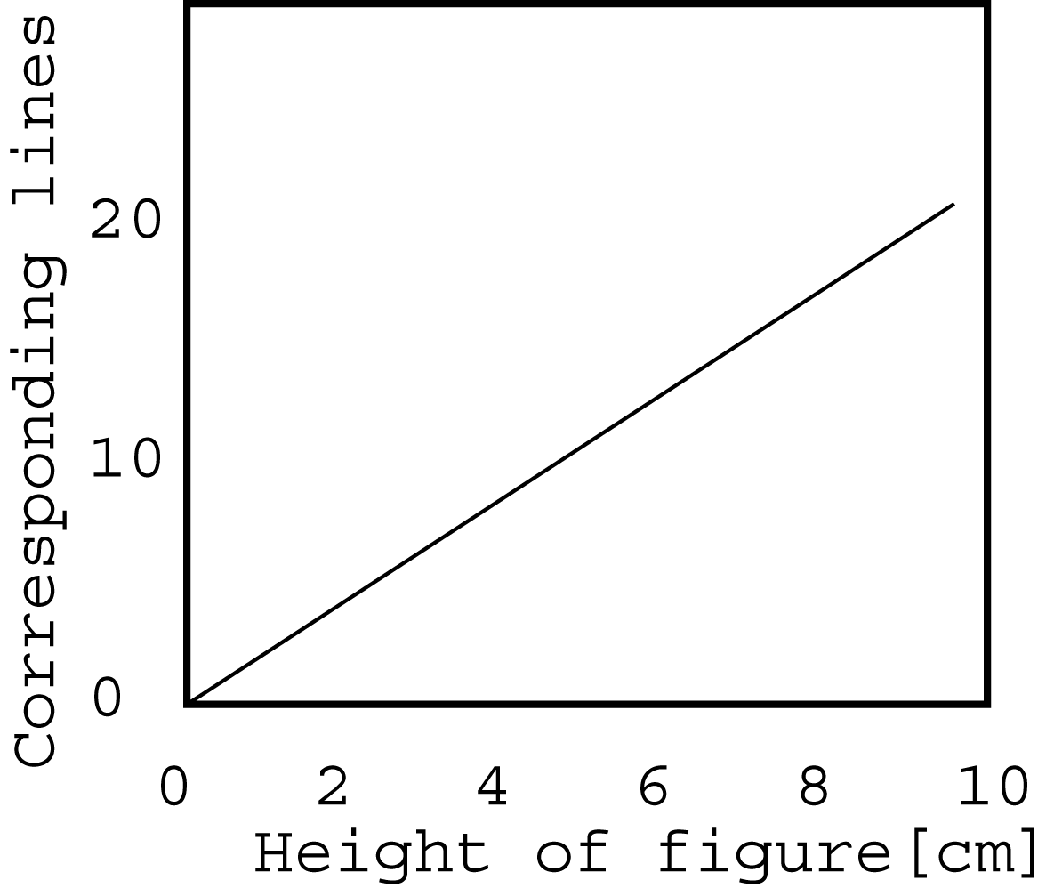
(small)

Fig. 1 SHINKU et al. “S”

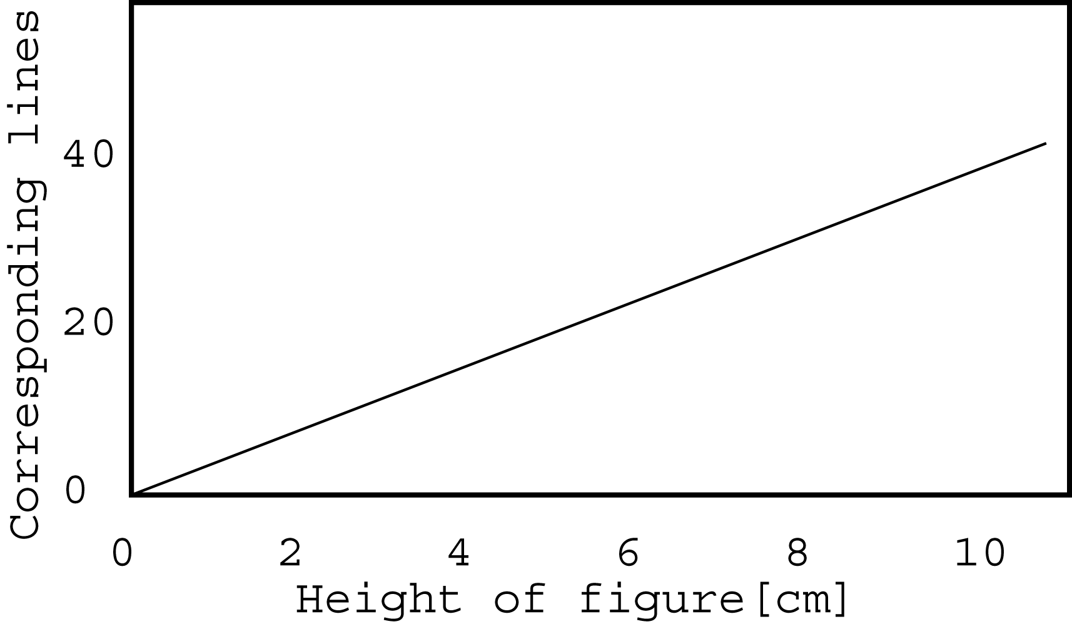
(Large)

Fig. 2 SHINKU et al. “L”
Table 1 SHINKU et al.

(Unit: Yen.)

